

Final Report - TOURNAMENT Tracker TEMPLATE APPLICATION

**Higher Diploma in Science in Computing**

Word Count: 4000

Higher Diploma in Science in Computing

* Web and Cloud Technologies

**Eoghan Butler**

10399096@mydbs.ie

05/09/2022

Supervisor - Clive Gargan

# Contents

1. Introduction 2

2. Background 3

3. Specification and Design 4

4. Implementation 11

5. Testing and Results 13

6. Conclusions and Future Work 14

7. References / Bibliography 16

8. Instructions for use 17

# Introduction

For my project I have developed a Tournament Tracker application. The purpose is for this application to be able to host, generate and save a knockout style tournament that could be used for videogames, a sport event, or any sort of group competition. This was done using Visual Studio 2022 using C# and developed as a Windows form application.

As stated in my previous reports, my original intention was looking to create a website that acts as a functioning template for tournaments. With it not only being hosted as a website, but also with the original intention of adding customisation so it would be tailored to a specific video game. However once proper work began on the project, I had to change my scope and shifted focus to entirely creating the functioning application due to the much greater level of work involved, than I had previously expected.

I had given more of a background in my interim report of the challenges I found myself facing and how I had to recalibrate my approach as I had fallen out of sync with my original timeline that I had planned. I essentially restarted my project at this stage which was a difficult decision to make. While I didn’t manage to salvage anything significant from my original code, I was able to use what I had learnt from the first attempt and to retrace my steps for the opening of the project in good time.

Fortunately, after my interim report and restarting the project, I was able to begin making good and consistent progress and have been able to complete my project to the level I was looking to achieve. As a result of lost time in the previous stages, I was set myself a strict work plan and managed to consistently stick to it to catch up. As a result, I fortunately reached the end of my project within the designated timeframe.

# Background

As previously stated, my project was to create a functioning knock out style tournament template application. I was also able to implement the planned functionality for a text file database. These had become my goals by the time of my interim report, and I did not deviate from it.

As previously detailed, one of the main goals that I set out to accomplish was to add more functionality to the tournament application compared to basic ‘one and done’ templates I had found online. Incorporating a database into the application would allow previous tournament information to be saved. But my original inspiration was that once you create a member or team, that they would be saved to the database and available for future selection. I used the real-life scenario of my friends and myself competing in videogame tournaments on a regular basis, as inspiration. Being able to avoid having to re-enter player information each time using the application would make it much more efficient and user friendly.

I had original plans to incorporate a SQL Server database and had previously included entity relationship diagrams in my interim report. This would have beneficial as the data for tournament results would be much more appealing to view and easy to understand immediately. However, the difficulty to implement the database far outweighed the benefits. When viewing the information, the text files, without familiarity it won’t make much sense. However, and more importantly, not only is user information saved, but previous tournament data and results are saved and can be viewed from the ‘Load Tournaments’ section. I felt that the data is very easy to view and understand this way that only using the text file database was more than sufficient.

In terms of software development methods used, the entirety of the project is being built within Visual Studio using the .Net Framework to create a Windows Form Application. As previously mentioned in my interim report, I had also explored and had begun making progress integrating compatibility with a SQL database into the project. But I will discuss that earlier plan in more detail later in the report.

# Specification and Design

In my interim report I had previously mentioned the requirements for the project I had planned to achieve:

**Requirements**

* **Variable tournament: The tournament application needs to be able to support a variable number of entrants.**
* Successful: This was able to be successfully created. In the tournament creation process a user can select and add the number of entrant teams they desire from a drop-down menu. There is also the option to remove a team from the tournament if they were selected in error. The same applies for adding and removing tournament prizes.
* **Placement ordering: Once the entrants are selected, the order they are put into the tournament should be at random.**

- Successful: Competing teams can be selected in any order, but once ‘Create Tournament’ is selected and you are brought to the ‘Tournament Viewer Form’, each time the teams will be assigned into rounds at random. Any free pass rounds (see section below) are also randomly allocated.

* Odd Entrants: if there is an odd number of entrants, something needs to be put into place so that the add person selected at random gets to skip the first round.
* Successful: When an odd number of players are entered into the tournament, an odd entrant selected at random would be skip a round and get entered straight into the subsequent round. This is displayed by their opponent simply being entered as <Free Pass>. When matched up, the entrant and the <Free Pass> both have a value of 0 entered in their score. However, it is coded behind the scenes that the <Free Pass> is considered the loser and the entrant automatically advances without having to input a score.  
  Additionally it is set up so that enough free passes will be allocated and spread out to ensure there is always an even number of brackets. For example, if there is five entrant teams, two will face off in one bracket, and the other three will be allocated free passes in three other brackets. This ensures there are an even four matches in the first round and not an odd three.
* **Games ordering: The games should be able to be played in whatever order the players choose. However, each round will need to be fully complete before the next round can begin.**
* Successful: In each round, all the matchups are displayed in the ‘matchuplistbox’. The user is free to select whatever matchup within this round and input the results data to proceed. So each round can be played out in whatever order the players decide. There is also ‘Unplayed Only’ button that can be toggled so that only the unplayed games will be displayed. If this button is selected, any games that are complete will automatically be removed from that rounds ‘matchuplistbox’ until no more are available. At that stage the next round is to be selected. And as intended, the next round will not be functionable until the preceding round is fully complete.
* **Create Prize: Offer users the choice of creating prizes for placement for a prize amount or prize percentage.**
* Successful: When creating a prize for the tournament users will have a choice of prize types. First they can create a prize for a specific placement (E.g first place, runner up) and they can select either a specific prize amount, or a certain percentage of the prize pool. This means there will be a record saved of what value was added to each prize.
* **Team entrants: The application will be formatted primarily so that participants can be entered as a team. In fact, this will be the base line for use. With individual participants still being able to enter they will however be recognised as a ‘team’.**
* Successful: In the ‘Create Team Form’ new entrants (members) can be created and in turn be added to the database. Once created, a team name can be chosen, and they can be added to that team. And number of members can be added to a team. E.g. Full multiple member teams can be created, or solo entrants can be created and just given their name as a team name.

Another design choice I had planned on since the start and finalised my choice by the interim report, was my text file database. I was very pleased with the results of this. While the once planned SQL database may have offered more visually pleasing data display, the text file database offers all the functionality I was looking for, and I was successfully able to implement it into each one of the forms in my application.

This means that there is a saved text file record of any tournament created with information such as: who entered, team placement, prize amount, who was in what rounds, results, etc.

While this not only provides a history for the players who enter, it also provides ease of use for people who will compete in tournaments using the application on more than one occasion. This is because any player and team created along with all their details are saved in the text files and can be used again. They will appear in the ‘select player’ and ‘select team’ drop-down menus as they have been wired up to the database. This should offer a level of convenience for players as they will save time using the application in a different tournament.

The final step of development for my project was styling the design of each of the forms. What inspired me to choose this application type for my project was to have a tournament app that could be used when playing the videogame Super Smash Bros Ultimate. I decided to style the project with artwork based on the game. This was a relatively straight forward step stating by finding images the correct size/resolution, and then selecting properties on each form, background image and then importing the correct image as a project resource file. This meant that instead of creating a local file path to each image, it would be saved into the project itself and they would be viewable on any computer the project is opened. It was then a case of through the properties just rearranging any tiles/windows in each form to align with any background images. Lastly, I also created a icon file so that in the top left of each form the is open in the application will have the logo from the game.

Here are what each form in the application looks like with the finished design:

**- The Tournament Dashboard From:**

The first form a user will see when they open the application.

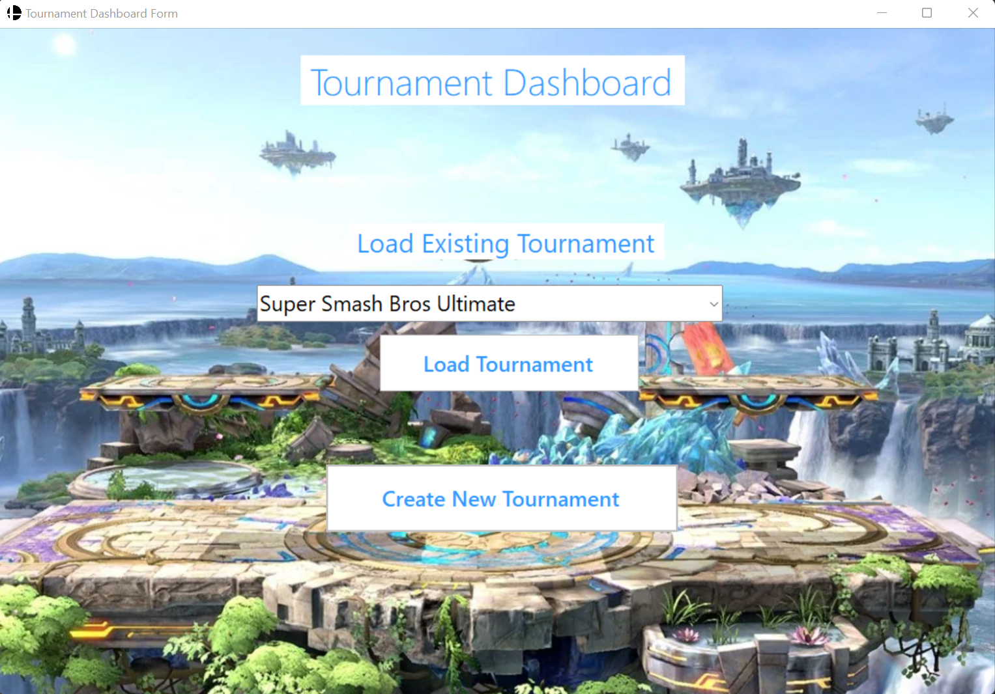

**- The Create Tournament Form:**

Where the tournament itself is created. Entrant teams and an entry fee can be selected here. Also, this is where users can access create new teams and create new prizes.

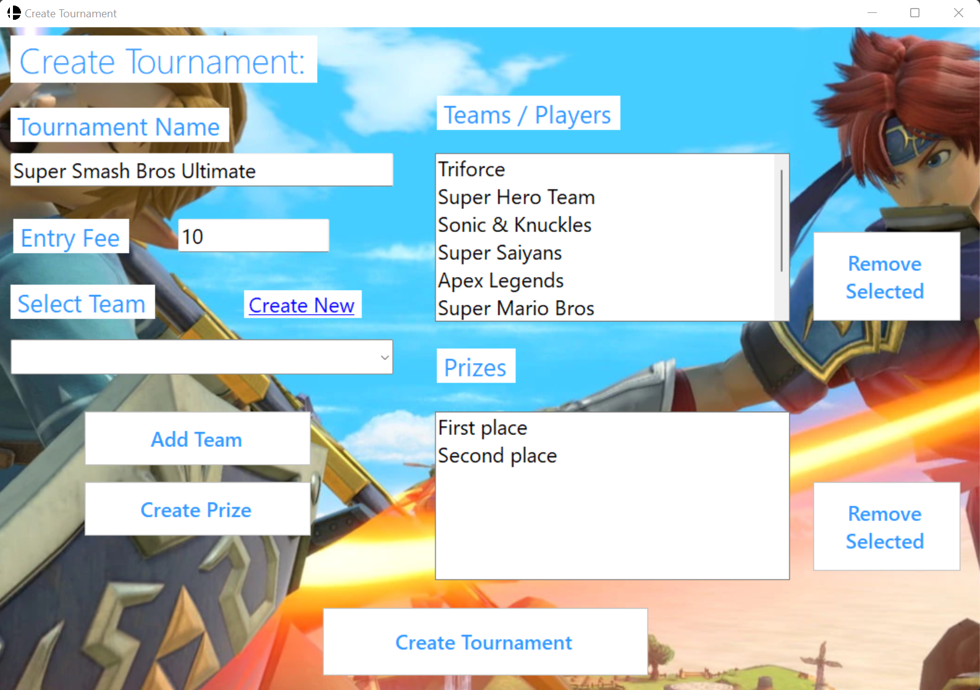

**- The Create Team Form:**

Here users can create individual members and teams. These will be saved in the text file database for future use.

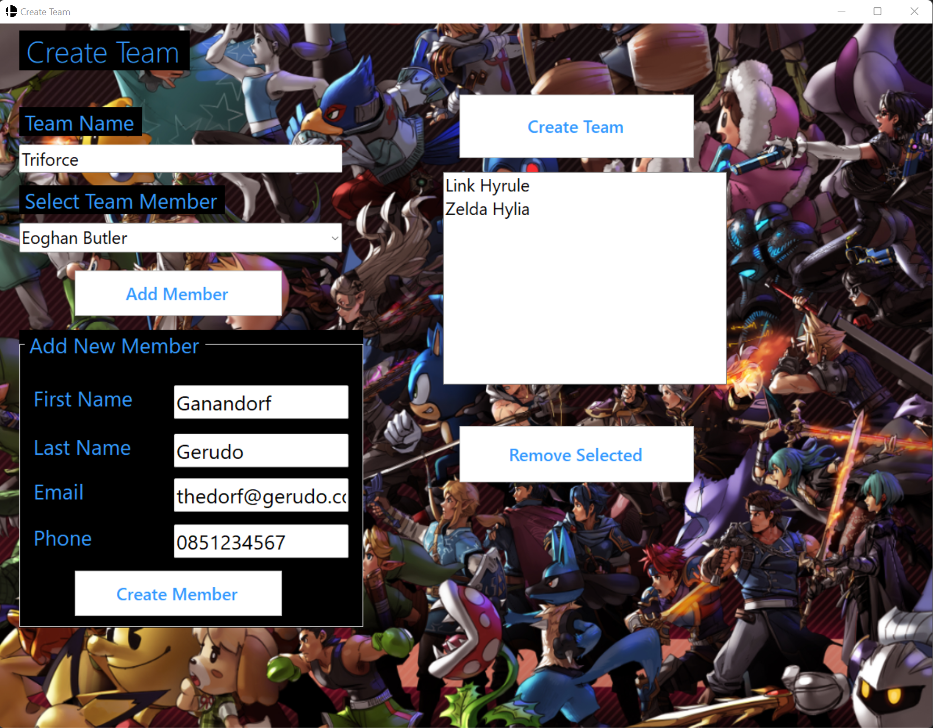

**- The Create Prize form:**

Prizes can be specified here by a specified amount or a percentage of the total entry fee pool.

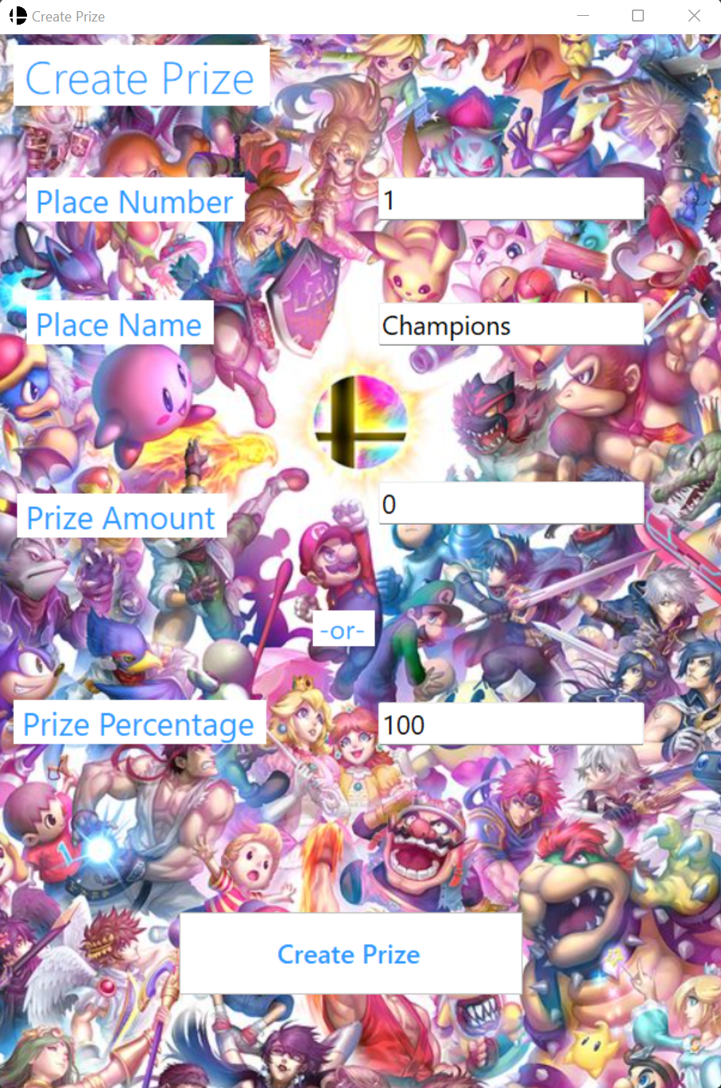

**-The Tournament Viewer Form:**

The final form off the application where users input the scores, work through the rounds until the tournament completion.

Once the final round concludes there is a congratulations message, and the tournament closes out back to the main dashboard form.

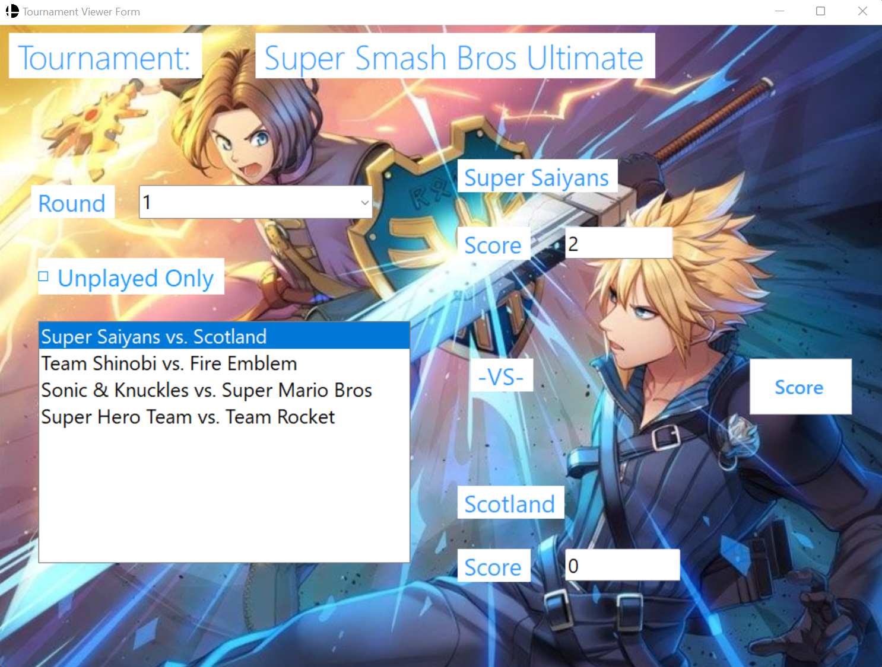

# Implementation

I used Visual Studio 2022 and NETFramework,Version=v4.7.2. (The latest available at this time). This can be verified on the App.Config section of the project.

As previously mentioned, the application was built as a Windows Form Application. This was done entirely through Visual Studio. Fortunately to develop a Windows Form Application I was able to use my previous experience with Visual studio, and some online research to get up to speed on the actual form design quick enough.

The text file database is coded into the project itself. All types of data input into the application (E.g., Teams, prizes, tournament matchups) are automatically saved into text files. In the Tournament UI, App.Config section I have specified the file path to a local file that happens to be inside my project folder for convenience. Each model saves a different batch of data.

The text file database appears in its chosen folder like this:

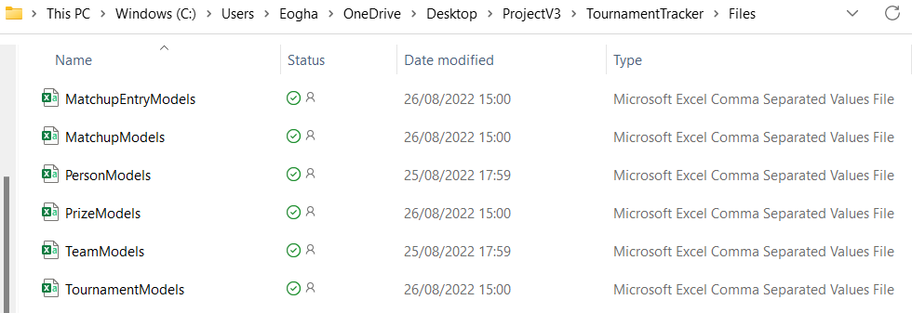

The data is save in these files and remains link to the application in future uses. For example, a saved team will remain saved and can be used in future tournaments. This data remains viewable in the application itself, but it can also be opened directly from these files.

While having a saved history of results is a nice feature, in practice they are a little bit more difficult to decipher from the text file database. For me for the real strength of the database is having previously saved players and teams ready to go for users to create and jump into a new tournament with ease.

When this project is being tested, this file path will have to be amended to a local file path on the tester’s computer, but I will include instructions on how to get the project to run on a different computer at the end of the report.

There was a great deal of trail and error research put into the functionality of each form. The structure and the layout of the windows forms was relatively straight forward, but the code behind the scenes, as expected, made up a tremendous amount of work. Fortunately, I was able to use my lecture materials from this course and a wealth of online information. I also found when creating the functionality for various buttons and menus on the forms, there was a fair amount of repletion which certainly helped. If a good foundation was put in place and it was done correctly the first time, you could reuse or repurpose sections of code several times throughout. This allowed for not only better efficiency, but also helped prevent small hard to spot errors.

# Testing and Results

The project can be broken down into each of the induvial ‘forms’ that can be seen on the user interface. As shown in my interim report, the base design and structure of the UI forms was done at the start of the project. However, the coding part for each form was done individually. The project would set to launch with a particular form to test and debug it. And with a great deal of trail an error, when I was satisfied, I could then move onto the next form. I would then repeat the process of closing off the next form and thoroughly working through it and then testing it. This approach proved to be very beneficial. I was able to isolate and focus entirely on one section at a time. And once it was done to completion, I could essentially tick it off an move on. This also meant that if/when I encountered errors when trying to call or link up with another form, I could identify more easily that it was a problem with my code to link them rather than anything in the previous form.

The more interactive elements on a page, the more testing was required. The ‘View Tournament Form’ being the last step of the application required the longest time. There was a lot of rules that had to be put in place to ensure the tournament progressed to the next round, free passes were given to odd number of entrants, etc.

There was also a great deal of testing to ‘break’ the project to find aspects that wouldn’t be good design so that we could put preventative measures in place. In the Create Prize Form for example, if someone is entering in a monetary among for the prize, that section should only accept decimal values. To circumvent this possible issue, steps were out in place so if that happened a pop-up window would appear to instruct the user that only decimal values can be entered for the prize amount.

Another example of this is in the Tournament viewer form. As it is a knockout style tournament there needs to be a winner to proceed to the next round, so a draw is not an acceptable result. There is a prompt put in place so if a result that is a draw is entered in any round, a message box will pop up instructing them that to proceed, “please play a rematch”.

While I also learnt from each phase of testing, I learnt my most valuable lesson from my biggest error which was the previous version of my project I messed up beyond use. I since created a folder of many backup versions of my project. Learning from my mistakes from an earlier build that I ruined, I decided to create a library of backups each time I would finish off a section. This meant that when I made mistakes later that I was unable to fix, I had a clear set of checkpoints I could revert to with minimal loss of work and time.

The result of the final stage of testing was as had hoped and expected. Each completed round proceeds to the next until the final is reached. Upon completion of the final, a congratulations message appears, the tournament closes out and the user is brought back to the main Tournament Dashboard, and the data of the results is saved into the database. The application was fully functional and then I was able to edit the design.

# Conclusions and Future Work

This project has been filled with challenges both expected and unexpected. I had to adjust the scope of my initial concept, scrap all my previous work, and start fresh.

There are some key points I can take away from the stage when I was trying to salvage work from my first attempt of the project that had become bugged beyond use. I am sure anyone who has coding experience can agree that when it comes to coding there are no shortcuts, and you need a solid foundation. In my head I thought the most effective path (but would have been a shortcut) to take would have been to try fix up my code despite making significant project breaking changes. Pushing the reset button and starting over was difficult to do but I wish I decided that path earlier rather than wasting time.

As detailed in my specification and design section, I managed to successfully meet all of the design and proposed functionality goals that I had set out in my interim report. By the time I reached my interim report I had clearer goals and a clearer idea of how to achieve them. While my original timeline became redundant, I set out a new stricter one at this stage that kept me on track and allowed me to complete everything in time.

One area where I felt I gained a lot of experience while building this project was how I greatly improve my debugging skills. Even when searching for a specific error code, it was often difficult to properly understand it and more importantly how to even begin go about fixing it. However, when presented with them and knowing what they were affecting or preventing from working gave me a better place to start from when trying to research them. By the end I was in a much more confident position when tackling errors, at least for the most part. Experience with Debugging a highly valuable and transferable skill that will benefit my ongoing progress.

Something I would like to do as future work is to successfully integrate a fully functioning SQL database. As mentioned in my previous report, I had ambitious plans in an earlier build of my project to build an SQL database but struggled to get the stored procedures to function correctly. While for the progress of my project deciding to scrap the SQL database was definitely the correct decision, I would like to refresh my experience on SQL and continue to build out the database. I feel it would be a better structured database and easier to understand due to its layout. While all the relevant information is available in the text files, you really need knowledge of how the project functions to be able to understand what that is representing. As mentioned, this information can also be viewed in an easy-to-understand manner by loading a previous tournament. But having an archive of all the previous results in an SQL database would be a nice feature.

A different functionality that would be interesting to incorporate is a round robin style of tournament so that every entrant/team plays a match against everyone else. Having the option to select from the two different tournament styles would give the application a great deal more functionality.

It would be a great addition or alternative. While creating that as well was certainly out of the scope of this project for me, it could be a good starting point for a future students work. Even if full integration of both tournament types would not be achievable, a great deal of this application (create team, create prize, create tournament forms) could likely be repurposed into a new separate project. Significant coding changes would need to be made to how the actual tournament itself functions to enable every entrant to pay one another. But a strong foundation for future work would be in place.

Fortunately, my final report is much more positive compared to where I left off on my interim report. This project required a tremendous amount of work, but I am satisfied with the finished outcome. This is an application that is fully functional, a pleasing design for its intended use (Super Smash Bros Ultimate Tournaments) and designed for repeated use thanks to the database integration. I intend to make use of this application in the future.

I have learnt a great deal throughout this whole course and in particular this project due the independent nature of its research and work. I feel confident I will be able to take what I have learnt and use it to help my own career progression as an IT professional.

# References / Bibliography

As this was an independent project without the lecture structure of previous modules, a lot of self study had to be done. Here the main resources I used:

● College lecture material and recordings,

● Youtube Tutorials

● Stackoverflow

● W3 Schools

● Microsoft Docs

● guru99

● c-sharpcorner

# Instructions for use

**Launching the project**

When opening the TournamentTrack.sln file, there are a few steps that need to be taken for it to run correctly.

After opening it up in Visual Studio, from the solution explorer you need to right click **TrackerUI** and then click set as **start-up project**. This will ensure that the project doesn’t try launching the TrackerLibrary first which will cause an error.

**Linking the text file database**

To make the text file database save the data from the application, a file path needs to be specified. This can be done by going to **App.config** within the **TrackerUI**. From here within the configuration, you need to input a file path on your local machine.

It should appear like the following with XYZ being your chosen file path:

<add key="filepath" value=" XYZ "/>

Once this is done and the application is run, this file path will begin to be populated with text files form the different forms and that data will also be reflected in the application. E.g., Previously created members/teams, previously created tournaments.